# **GARAGE MANAGEMENT SYSTEM**

COLLEGE NAME:KARUPPANNAN MARIAPPAN COLLEGE

COLLEGE CODE:bru3s

TEAM ID:NM2025TMID28647

TEAM MEMBERS:

Team Leader:

ABARNA S

Email: [abarna274@gmail.com](mailto:abarna274@gmail.com)

Team Member1:

MANIKANDAN M

Email: [rolexpandiyan9@gmail.com](mailto:rolexpandiyan9@gmail.com)

Team Member2:

ARTHI S

Email: [arthi2366@gmail.com](mailto:arthi2366@gmail.com)

Team Member3:

BHARATHI K

Email: [bharathikannan9942@gmail.com](mailto:bharathikannan9942@gmail.com)

INTRODUCTION:

Project Overview:

The Garage Management System is a comprehensive web based tool designed to streamline and optimize the operation of a garage. Built on the salesforce platform,this system offers a centralized platform for managing vehicle records,service appointments,billing,and customer feedback.

Purpose:

The system leverage salesforces features like custom objects,reports,dashboards,and automation tools to enhance the overall efficiency of managing a garage.This project aims to reduce operational delays,improve customer experience,and ensure real-time tracking of all service activities.

DEVELOPMENT PHASE:

Creating Development Account:

By using this URL – <https://developer.salesforce.com/signup>

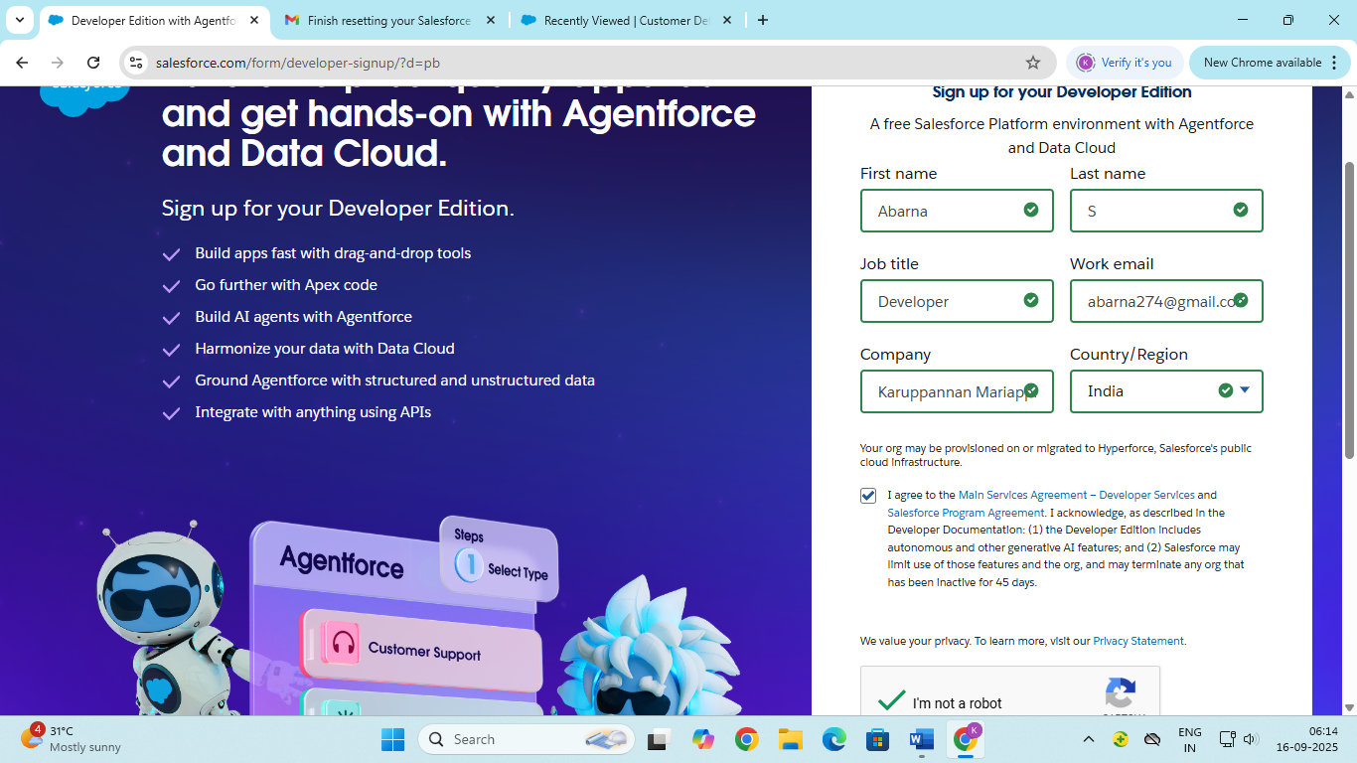

Account Activation:

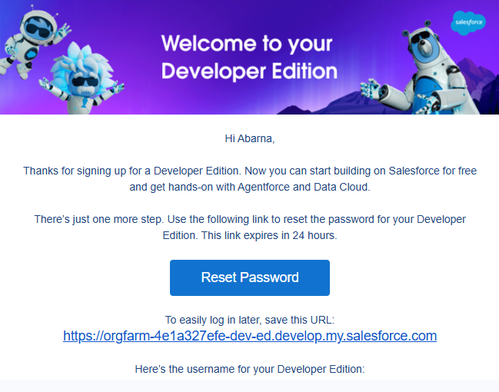

Create Customer Details Object:

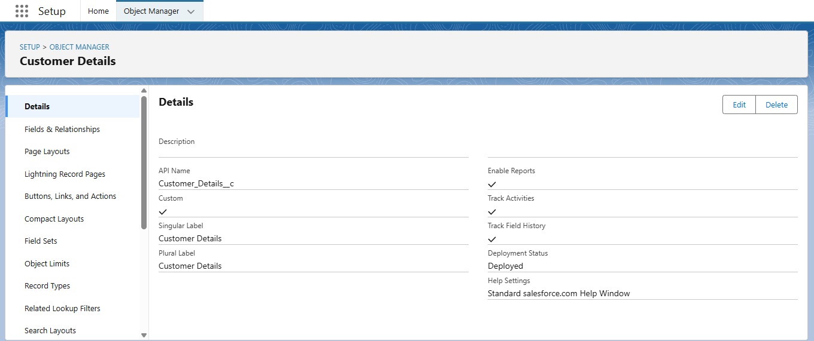

Create Appointment Object:

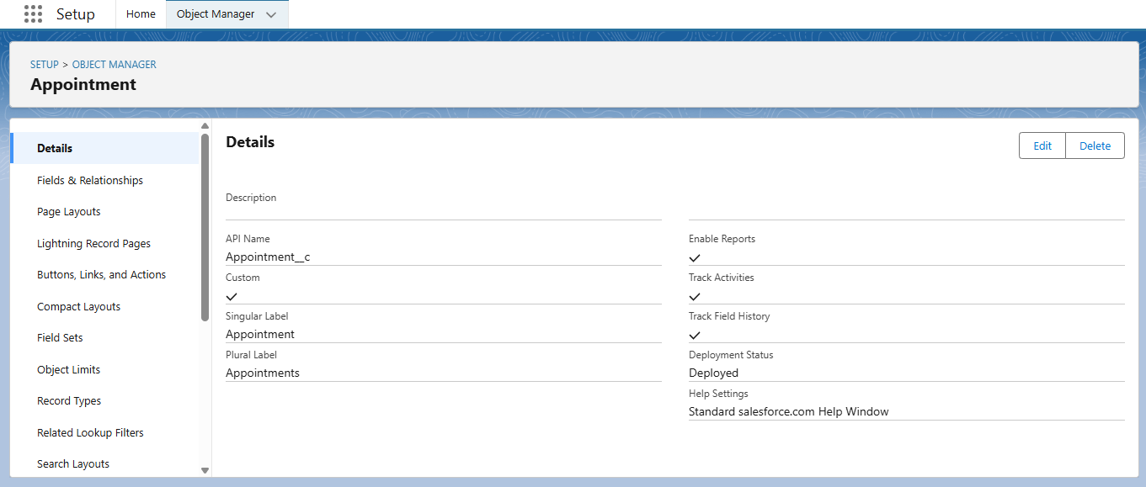

Create Service Records Object:

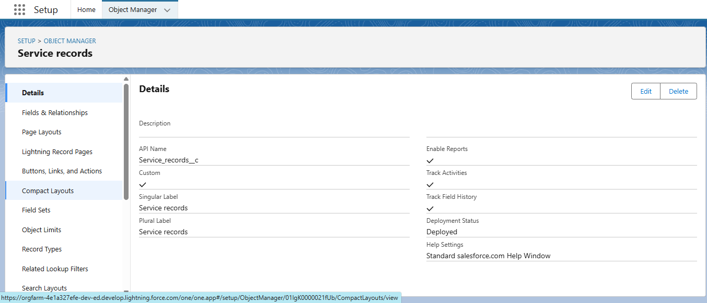

Create Billing Details and Feedback Object:

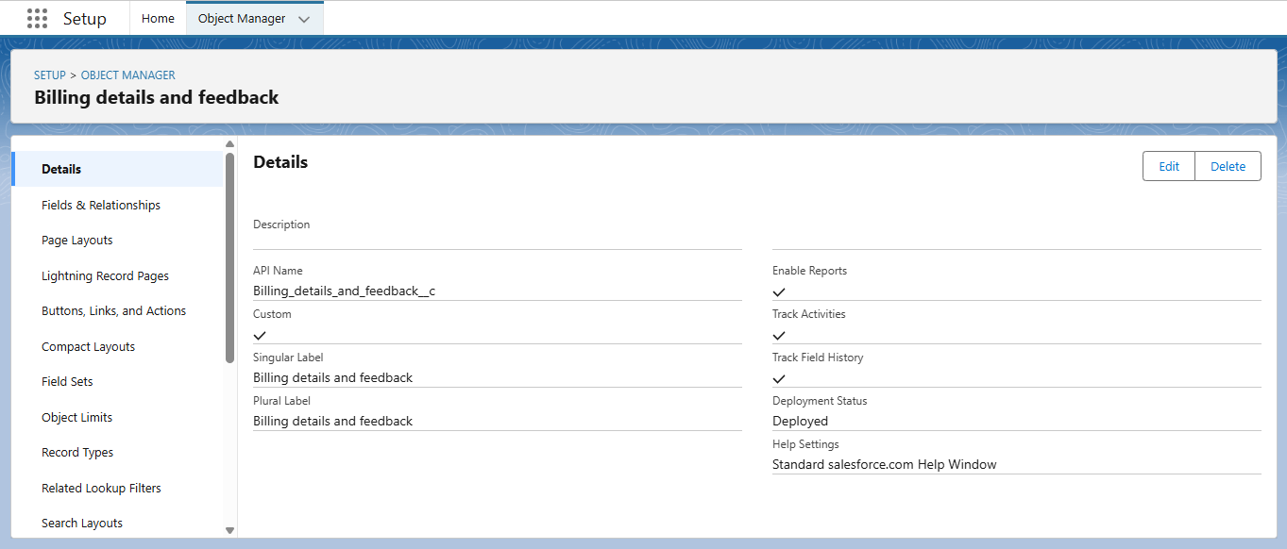

Creating a Custom Tab:

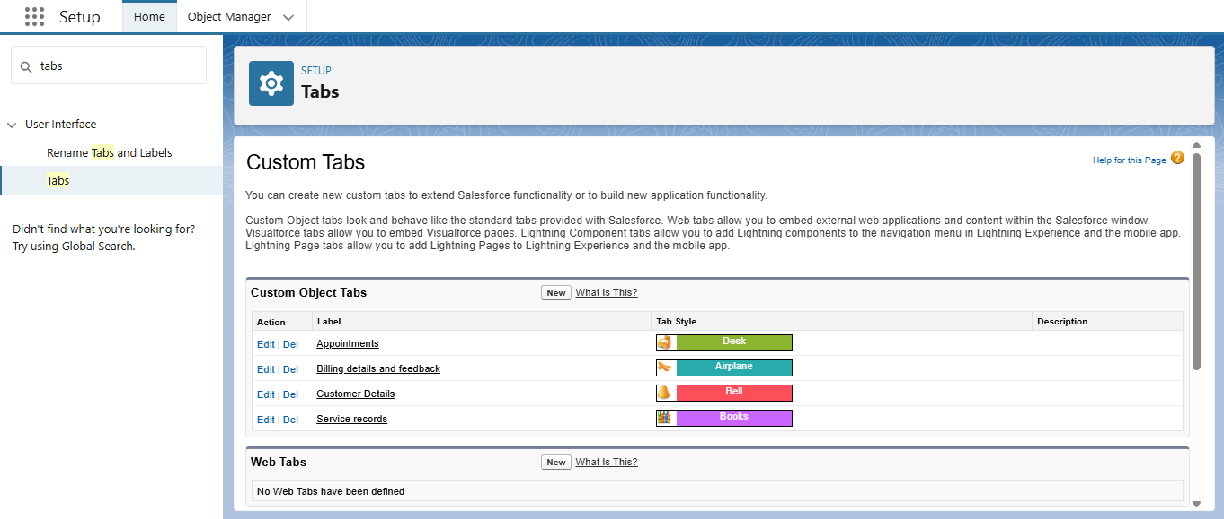

Create a Lighting App:

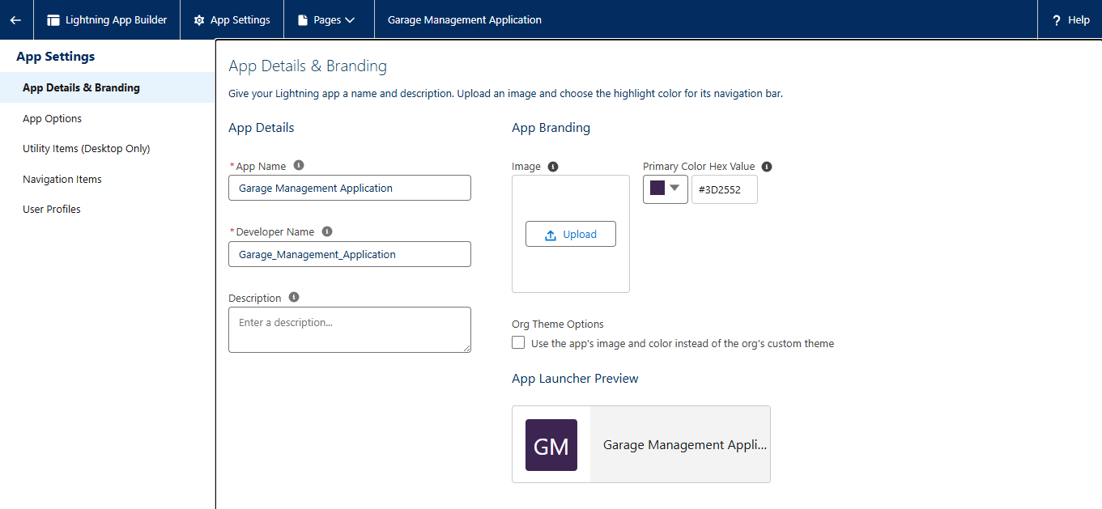

Creation of Fields the Customer Details Object:

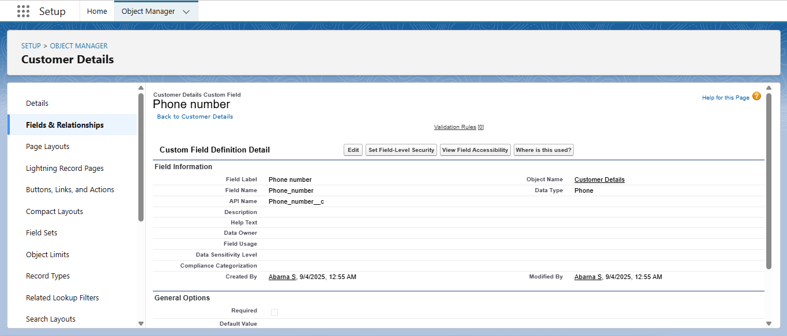

Creation of Lookup Fields:

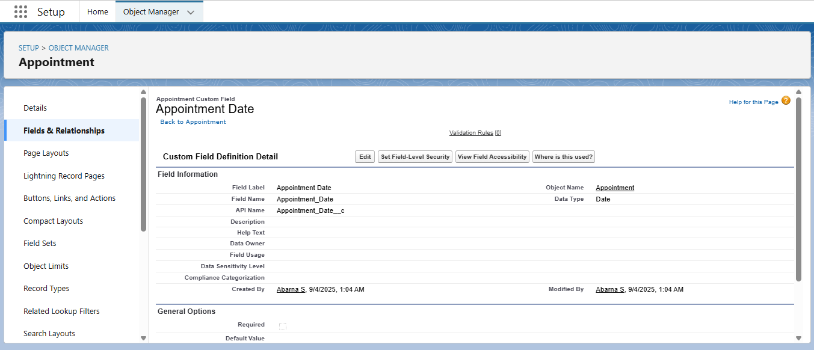

Creation of Checkbox Fields:

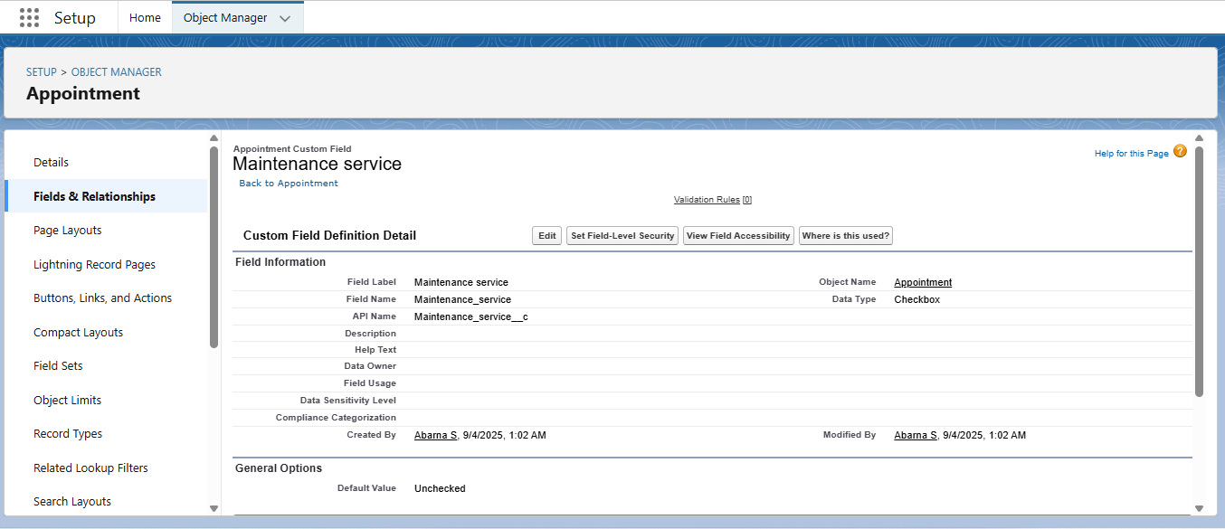

Creation of Currency Fields:

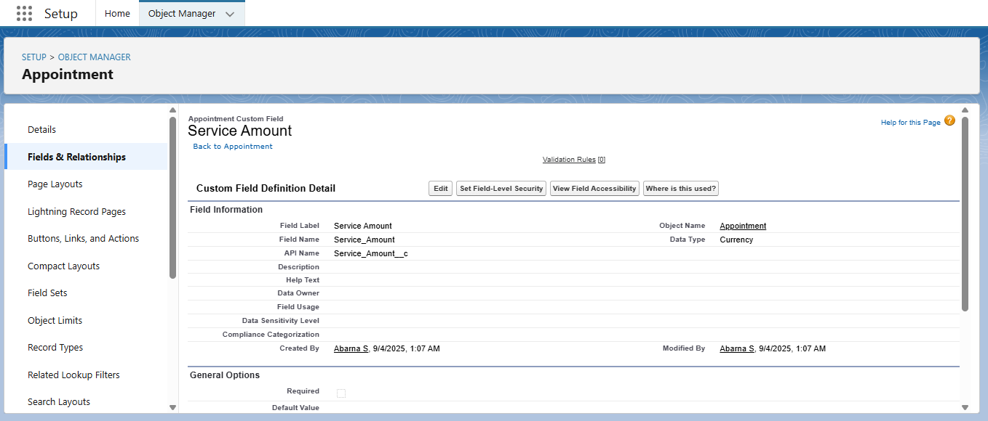

Creation of Text Fields:

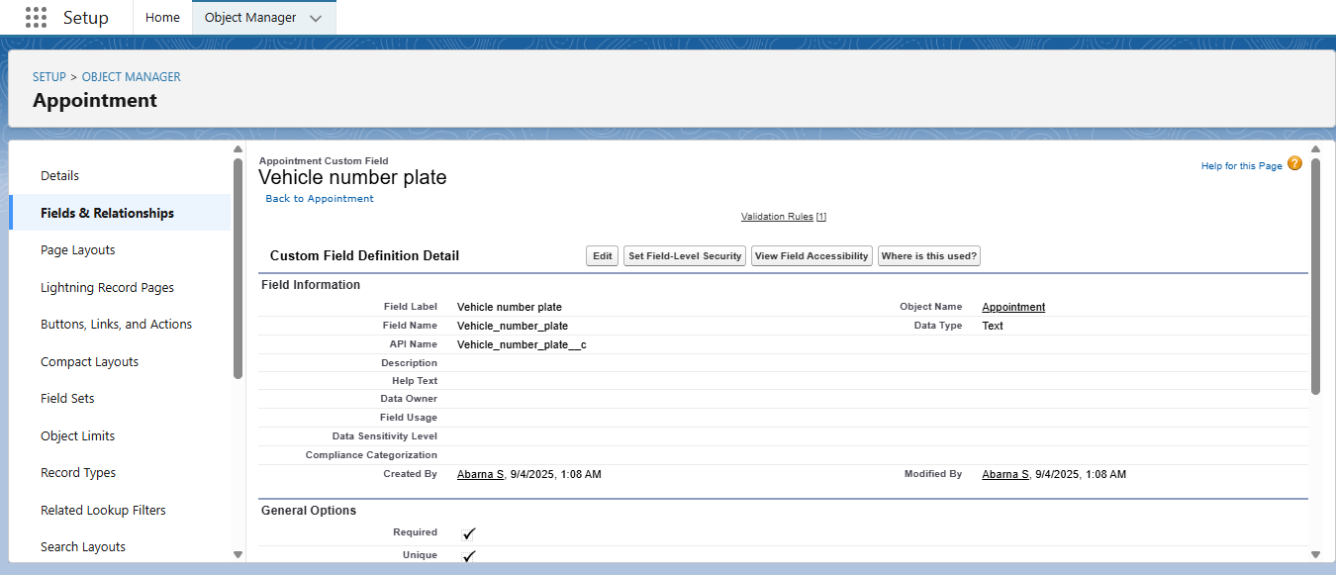

Creation of Picklist Fields:

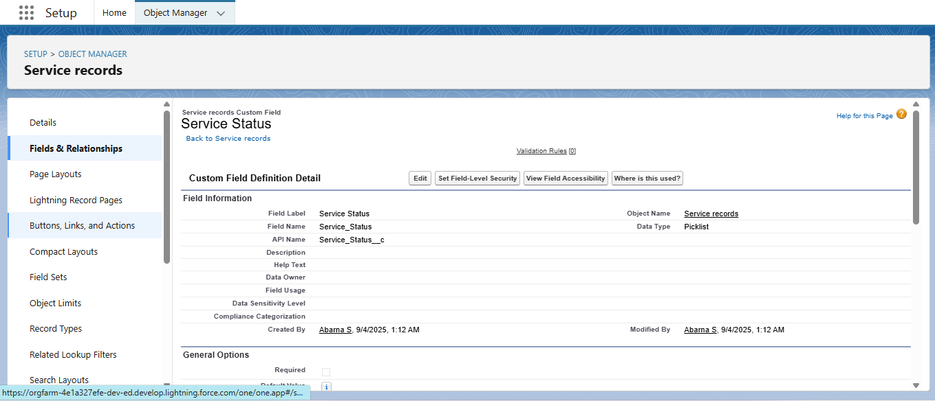

Creating Formula Field in Service Records Object:

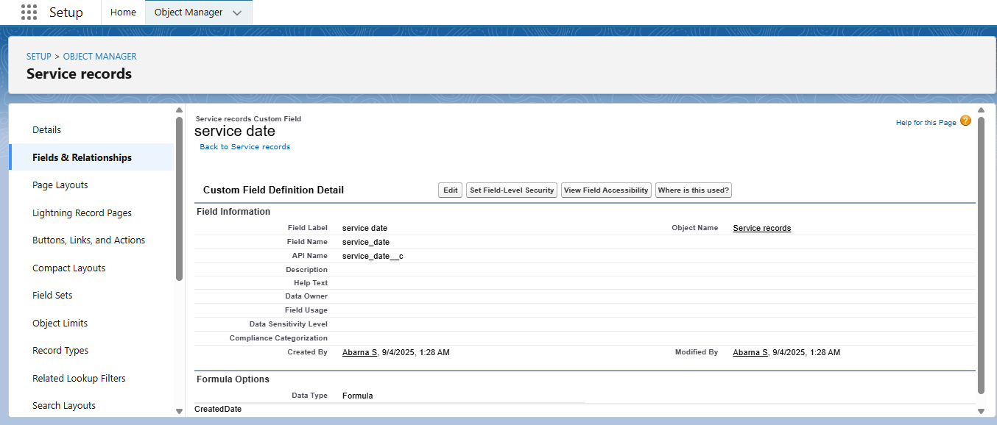

To Create a validation Rule to an Appointment Object:

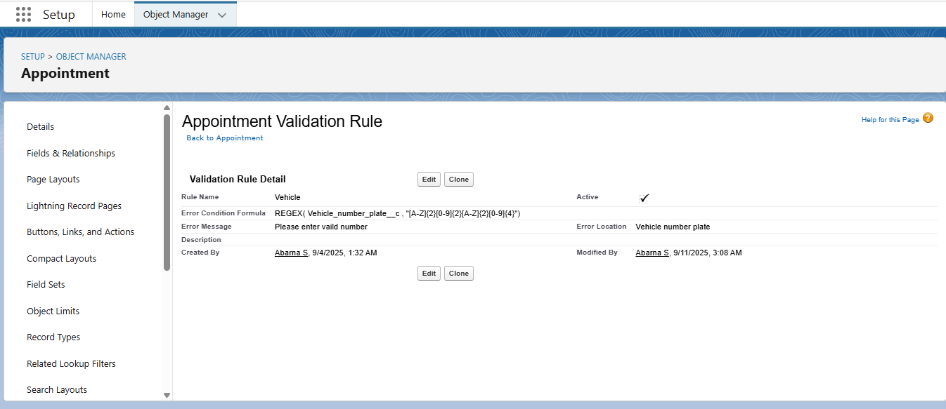

To create a Matching Rule to a Customer Details Object:

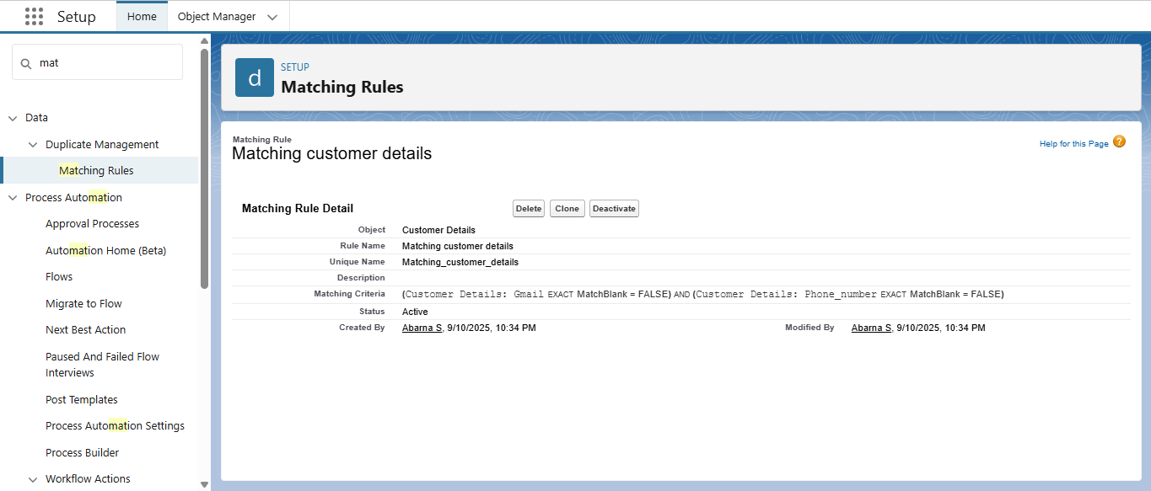

To create a Duplicte Rule to a Customer Details Object:

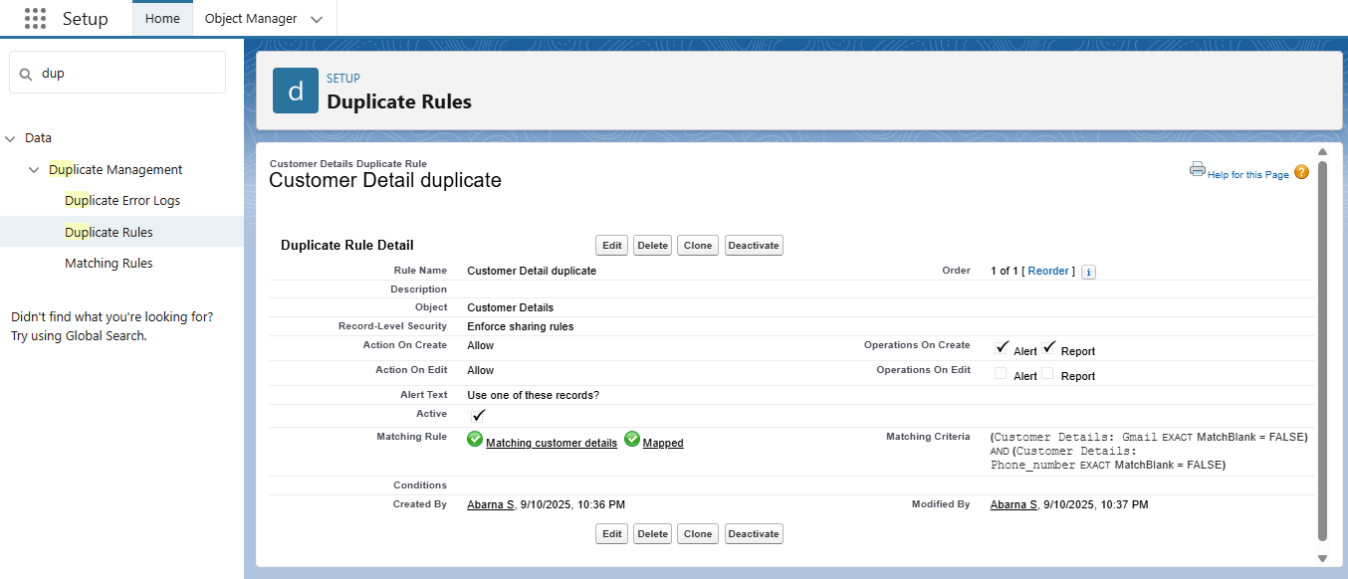

Manager Profile in Standard User:

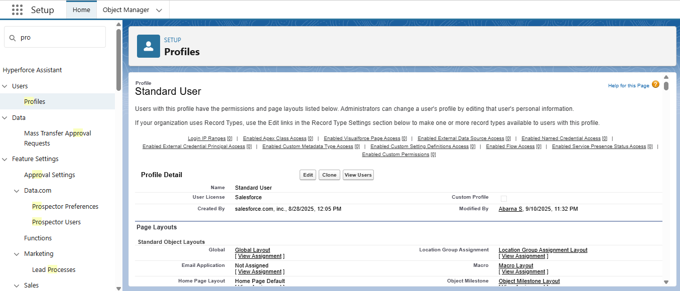

Salesperson Profile:

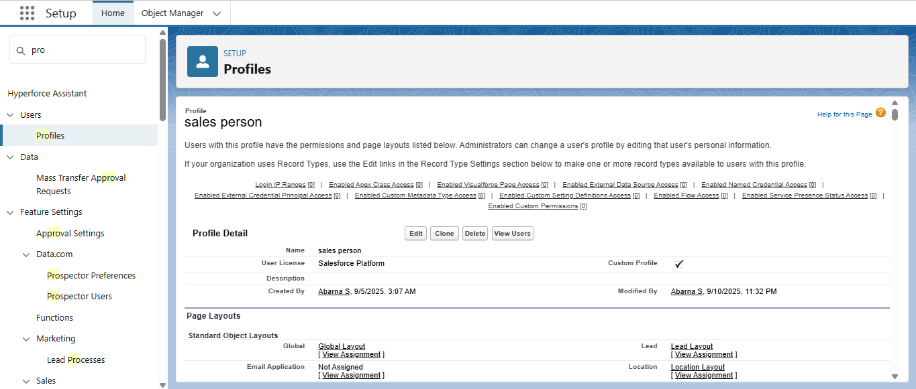

Creating Manager Role:

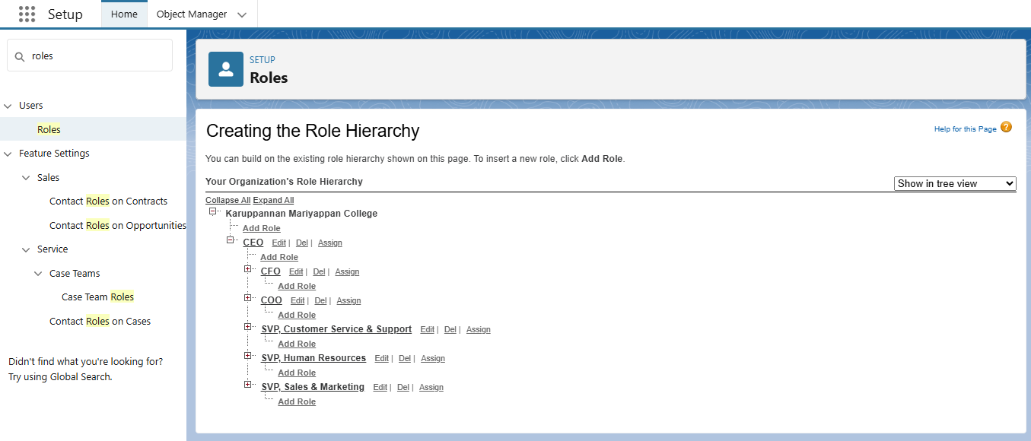

Creating Another Role:

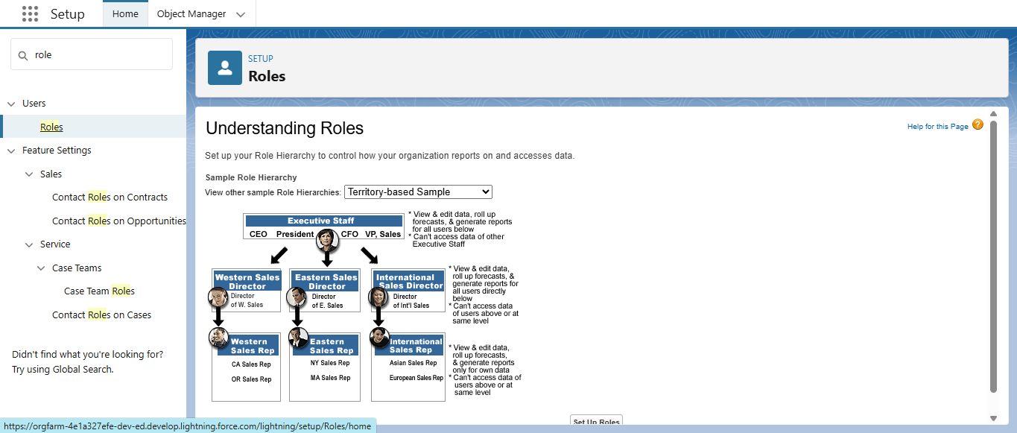

Create User:

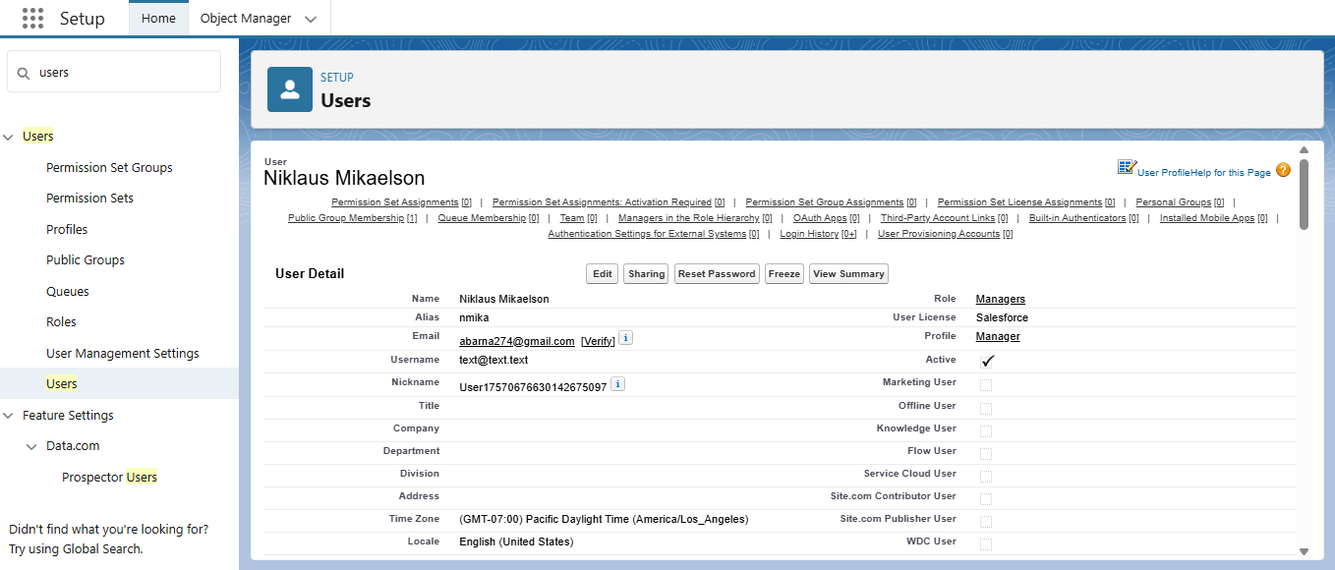

Creating New Public Group:

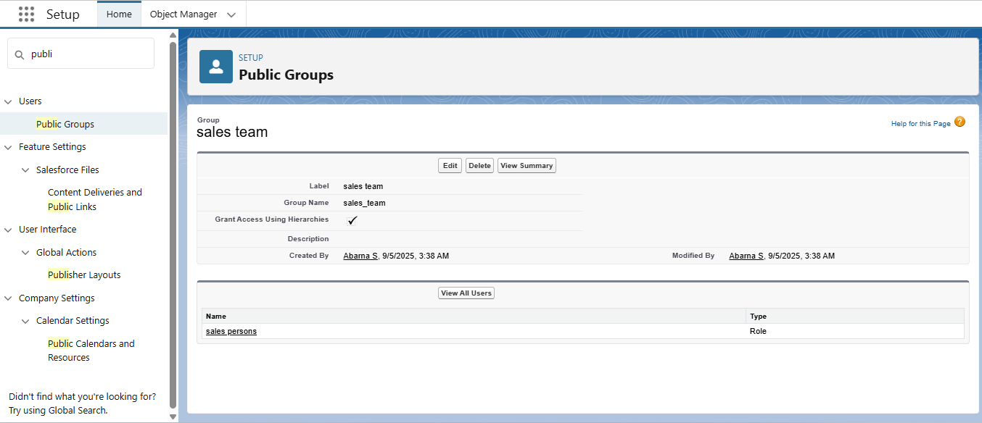

Creating Sharing Settings:

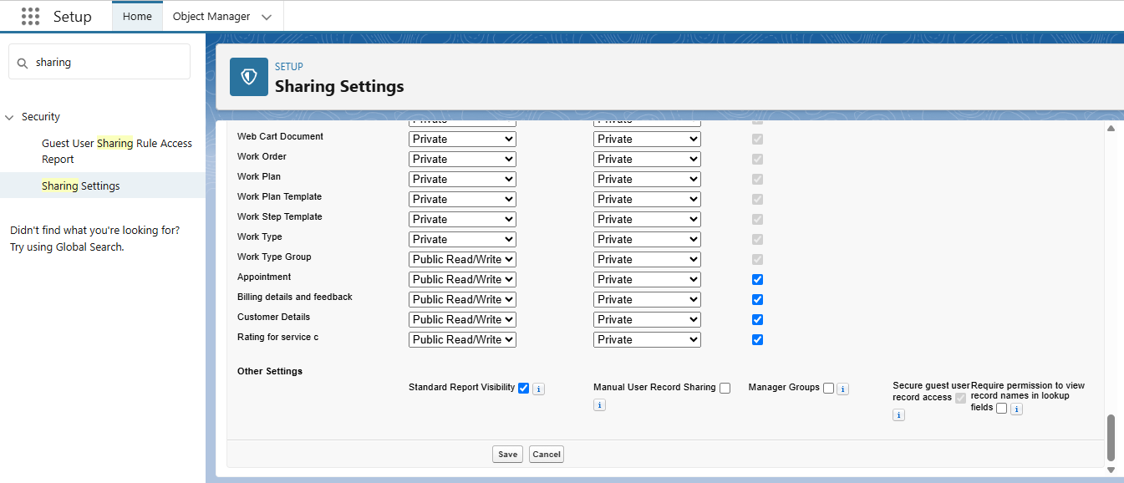

Create a Flow:

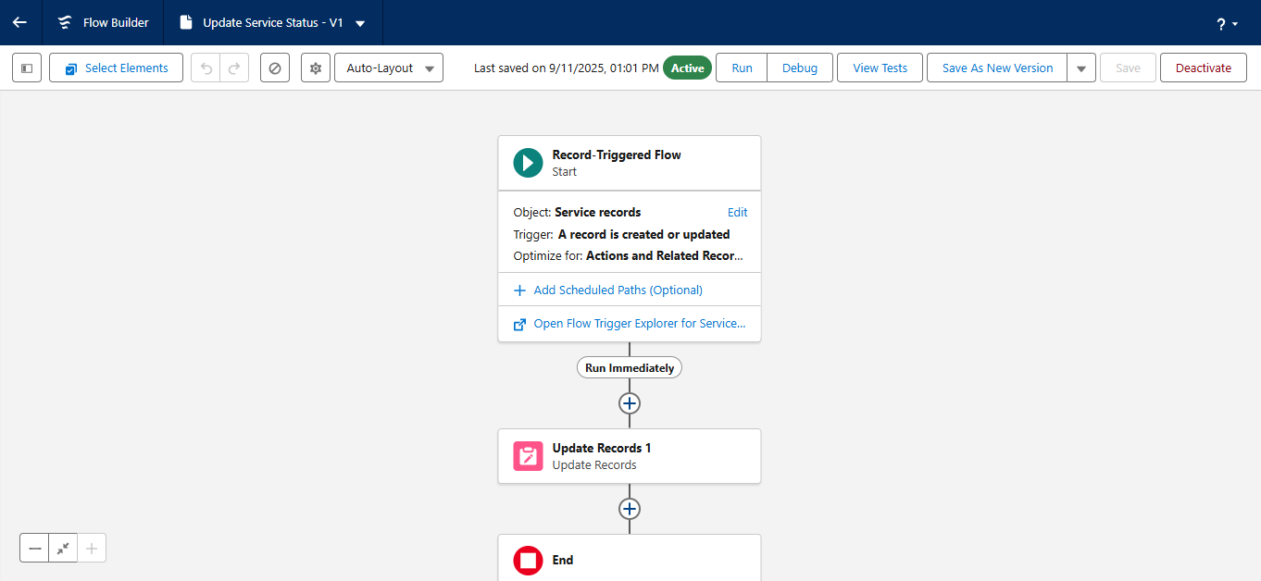

Apex Handler:

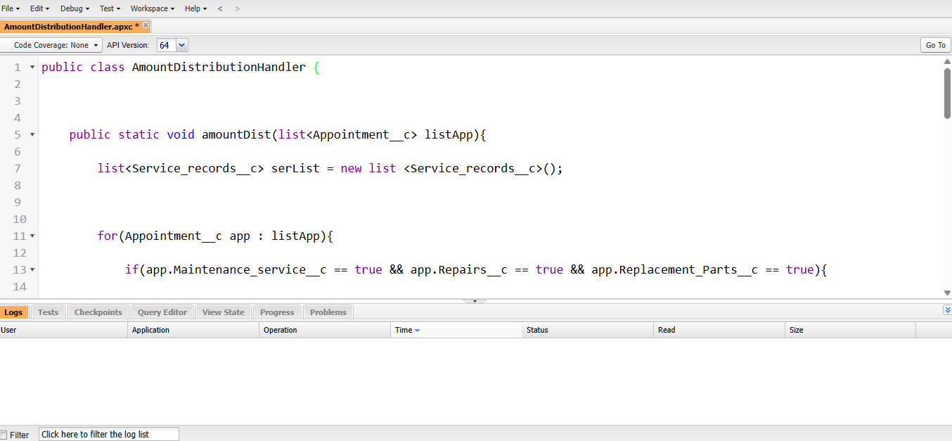

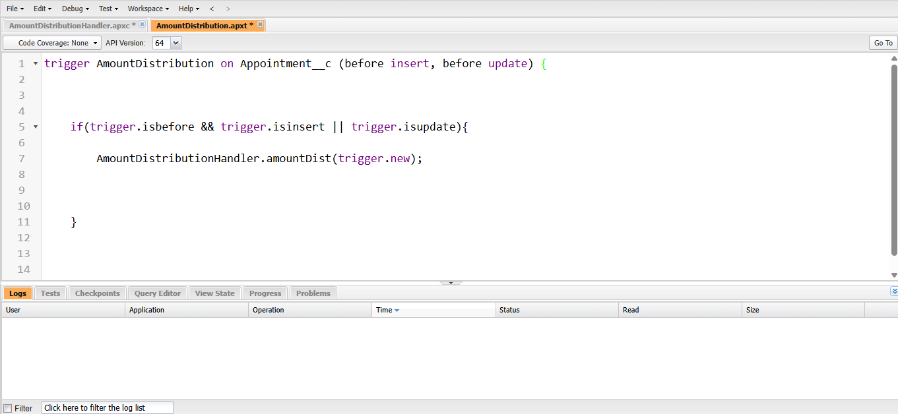

Sharing a Reports Folder:

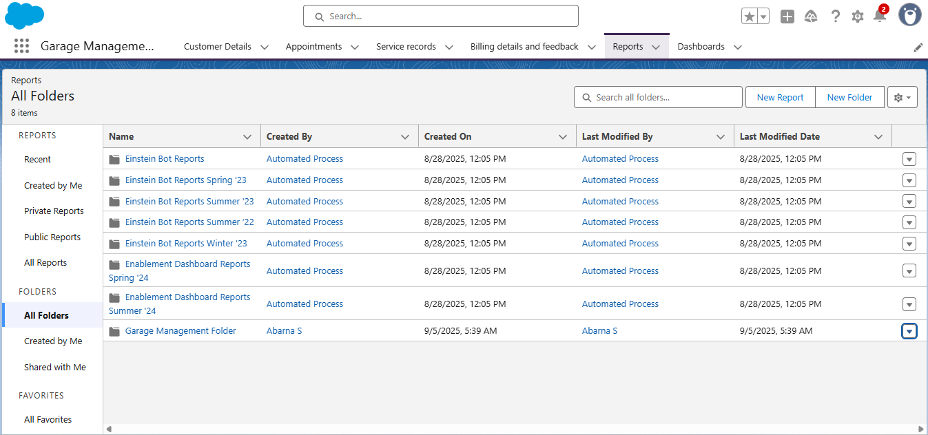

Create a Share Folder:

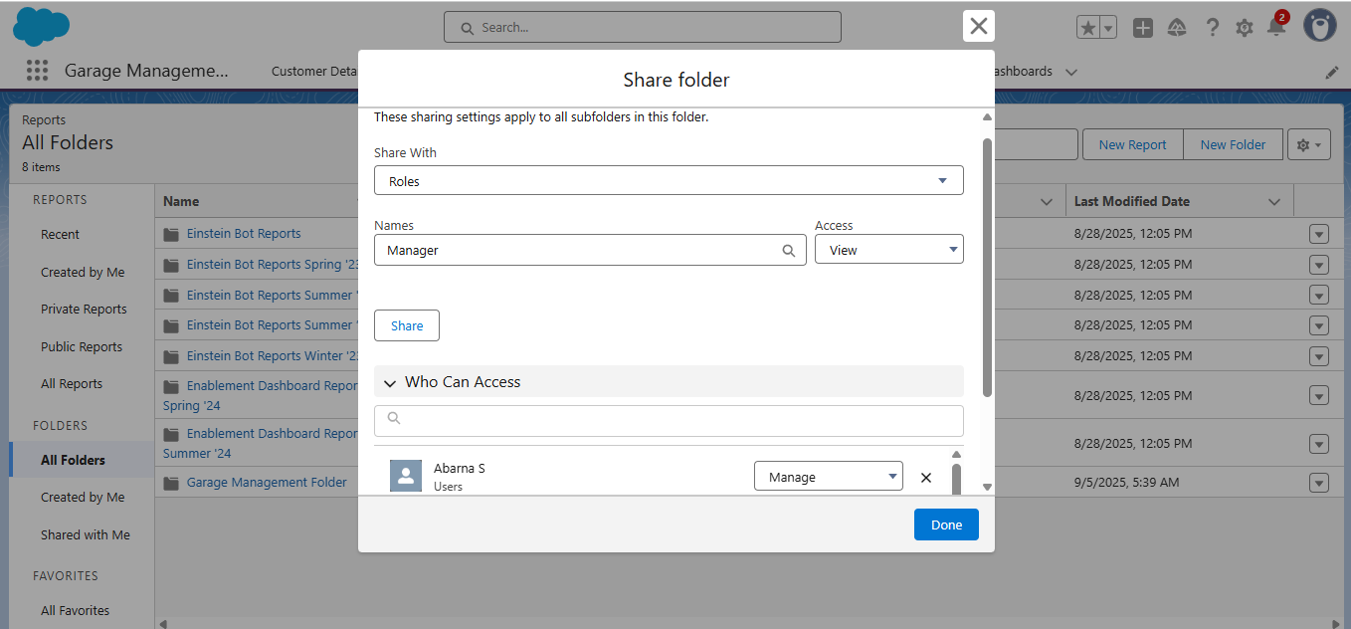

Create a Report Folder:

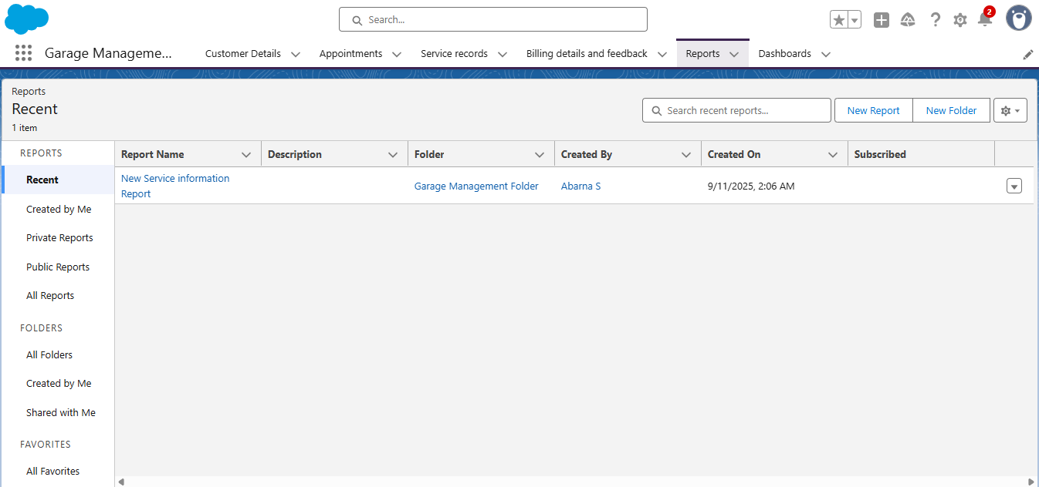

Create a Dashboard Folder:

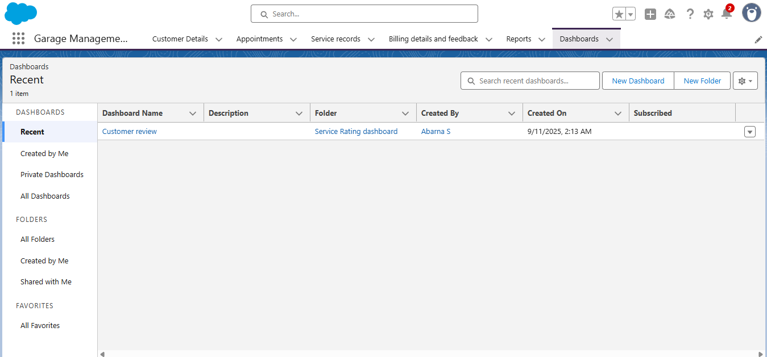

Creating Appointment Records:

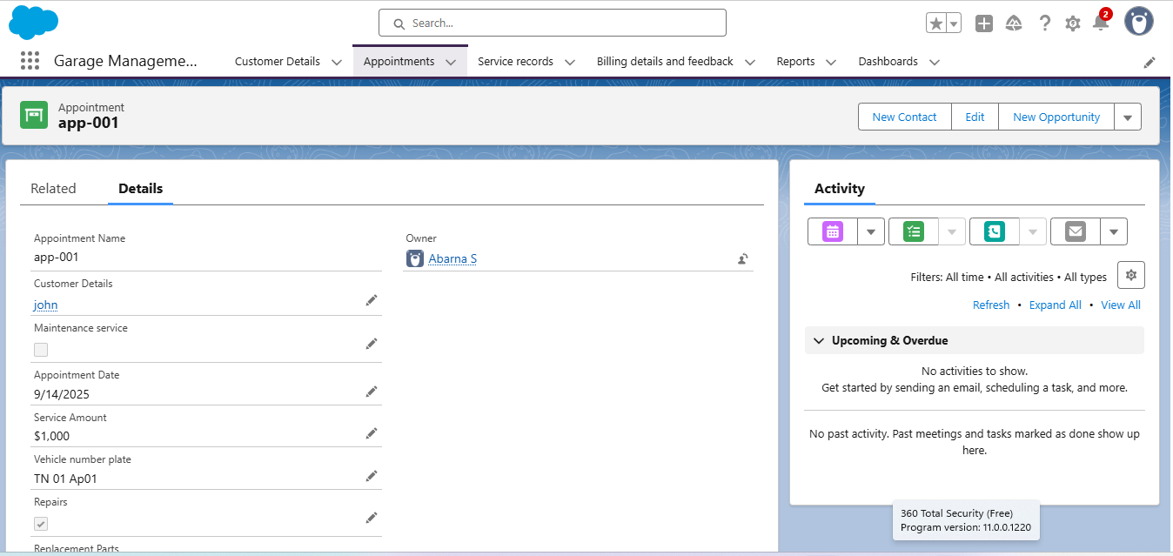

Creating a Service Records:

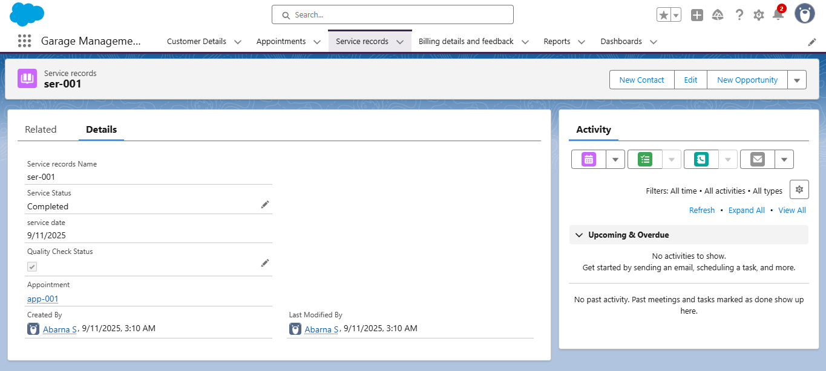

CONCLUSION:

The Garage Management System is a comprehensive solution designed to streamile and optimize garage operations.By automating tasks,managing inventory,tracking customer information,and providing real-time updates,this system enchances efficiency,productivity,and customer Satisfaction.